https://www.ftc.gov/news-events/press-releases/2019/10/multi-level-marketer-advocare-will-pay-150-million-settle-ftc

Multi-Level Marketer AdvoCare Will Pay $150 Million To Settle FTC Charges it Operated an Illegal Pyramid Scheme
October 2, 2019
Multi-level marketer AdvoCare International, L.P. and its former chief executive officer agreed to pay $150 million and be banned from the multi-level marketing business to resolve Federal Trade Commission charges that the company operated an illegal pyramid scheme that deceived consumers into believing they could earn significant income as “distributors” of its health and wellness products. Two top promoters also settled charges that they promoted the illegal pyramid scheme and misled consumers about their income potential, agreeing to a multi-level marketing ban and a judgment of $4 million that will be suspended when they surrender substantial assets.
The FTC complaint filed in federal court also charges two other top AdvoCare promoters, Danny and Diane McDaniel, with unlawfully promoting a pyramid scheme, making deceptive earnings claims, and providing others with the means and instrumentalities to do the same.
The FTC alleged that Texas-based AdvoCare promoted a business opportunity distributing health and wellness products, such as its Spark energy drink, through a network of hundreds of thousands of participants, known in the company as distributors. AdvoCare pitched its business opportunity through conferences, webinars, conference calls, podcasts, social media posts, videos, and print materials, according to the FTC’s complaint.
In its complaint against AdvoCare, former CEO Brian Connolly, and distributors Carlton and Lisa Hardman and Danny and Diane McDaniel, the FTC alleged that the parties falsely claimed to offer a life-changing financial solution that would allow any ordinary person to earn unlimited income, attain financial freedom, and quit their regular job.
In reality, the FTC alleged, the vast majority of AdvoCare distributors have earned no money or lost money.
“Legitimate businesses make money selling products and services, not by recruiting. The drive to recruit, especially when coupled with deceptive and inflated income claims, is the hallmark of an illegal pyramid.” said Andrew Smith, Director of the Bureau of Consumer Protection. “The FTC is committed to shutting down illegal pyramid schemes like this and getting money back for consumers whenever possible.”
According to the FTC, AdvoCare operated an illegal pyramid scheme that pushed distributors to focus on recruiting new distributors rather than retail sales to customers. The compensation structure also incentivized distributors to purchase large quantities of AdvoCare products to participate in the business and to recruit a downline of other participants with the same incentives. The clear directive of this structure was, as one AdvoCare distributor explained during the company’s Success School training, to “recruit business builders who recruit business builders who recruit business builders. . . .”
The FTC alleged that under the AdvoCare compensation plan, participants were charged $59 to become a distributor, making them eligible to receive discounts on products, and to sell products to the public. To earn all possible forms of compensation, however, participants had to become “advisors,” which typically required them to spend between $1,200 and $2,400 purchasing AdvoCare products and accumulate thousands of dollars of product purchase volume each year, according to the complaint. The FTC alleged that the income of AdvoCare advisors was based on their success at recruiting, with the highest rewards going to those who recruited the most advisors and generated the most purchase volume from their downline.
To recruit people, the FTC alleged, AdvoCare and the other defendants told distributors to make exaggerated claims about how much money average people could make—as much as hundreds of thousands or millions of dollars a year. The FTC alleged that distributors were told to create emotional narratives in which they struggled financially before they joined AdvoCare, but obtained financial success through AdvoCare. Distributors were also allegedly told to instill fears in potential recruits that they would suffer from regrets later if they declined to invest in AdvoCare.
The FTC alleged that the defendants told consumers that they could realize large incomes by promoting AdvoCare and that their earning capacity was limited only by their effort. For example, AdvoCare promoter Diane McDaniel told consumers that “the sky is the limit. I’m the variable. I get to decide what I truly want according to the effort I put forth” and that “there is incredible profit that can be made through infinity.”
In reality, the FTC alleged, AdvoCare did not offer consumers a viable path to financial freedom. In 2016, 72.3 percent of distributors did not earn any compensation from AdvoCare; another 18 percent earned between one cent and $250; and another 6 percent earned between $250 and $1,000. The annual earnings distribution was nearly identical for 2012 through 2015.
In addition to a $150 million judgment and a permanent ban on multi-level marketing, the settlement order with AdvoCare and Connolly requires them to notify all AdvoCare distributors about the FTC’s lawsuit and settlement, and to advise them that:
- they will no longer be able to earn compensation based on purchases of distributors in their downline;
- if they had significant losses pursuing their AdvoCare business, they may get some of their money back from the FTC; and
- if they decide to discontinue their participation in the business opportunity, AdvoCare offers a 100 percent refund on unused products under existing refund policies.
The Commission vote authorizing the staff to file the complaint and stipulated final order/injunction was 5-0. The FTC filed the complaint and final order/injunction in the U.S. District Court for the Eastern District of Texas.
NOTE: The Commission files a complaint when it has “reason to believe” that the named defendants are violating or are about to violate the law and it appears to the Commission that a proceeding is in the public interest. Stipulated final injunctions/orders have the force of law when approved and signed by the District Court judge.
The Federal Trade Commission works to promote competition, and protect and educate consumers. You can learn more about consumer topics and file a consumer complaint online or by calling 1-877-FTC-HELP (382-4357). Like the FTC on Facebook, follow us on Twitter, read our blogs, and subscribe to press releases for the latest FTC news and resources.

FTC Blog

FTC: AdvoCare business model was pyramid scheme
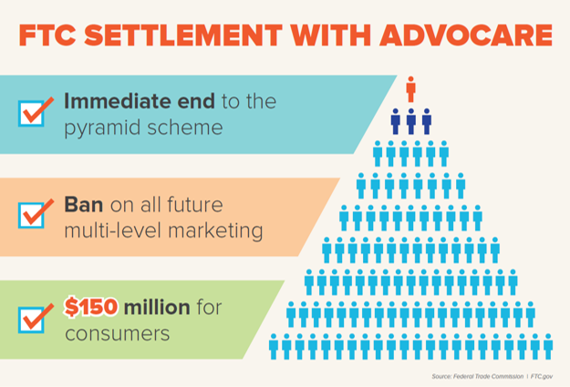
According to the FTC, people paid AdvoCare thousands of dollars to become “distributors,” buy inventory, and become eligible for cash bonuses and other rewards. But, the FTC says, AdvoCare rewarded distributors not for selling product but for recruiting other distributors to spend large sums of money pursuing the business opportunity. That push to recruit is a classic sign of a pyramid scheme.
Under a landmark settlement, AdvoCare and its former chief executive will pay $150 million for consumer refunds. They’re also banned from all multi-level marketing. Two of AdvoCare’s top promoters also have settled with the FTC for $4 million, most of which is suspended, based upon their inability to pay. They, too, are banned from multi-level marketing. The FTC’s case against two other leading AdvoCare promoters is continuing.

https://www.ftc.gov/enforcement/cases-proceedings/162-3109-419-cv-00715/advocare-international-lp.

AdvoCare International, L.P.

- TAGS: Franchises, Business Opportunities, and Investments deceptive/misleading conduct Consumer Protection Advertising and Marketing Going into Business Bureau of Consumer Protection Southwest Region
LAST UPDATED: OCTOBER 2, 2019
CASE STATUS: Pending
Federal Trade Commission, Plaintiff, v. AdvoCare International, L.P., a limited partnership; Brian Connolly; Danny McDaniel; Diane McDaniel; Carlton Hardman; and Lisa Hardman; Defendants.
FTC MATTER/FILE NUMBER: 162 3109
CIVIL ACTION NUMBER: 4:19-cv-00715
FEDERAL COURT: Eastern District of Texas
CASE TIMELINE

October 2, 2019
Complaint for Permanent Injunction and Other Equitable Relief (354.69 KB)
Unopposed Motion to Enter Stipulated Orders for Permanent Injunction and Monetary Judgments Against Defendants AdvoCare International, L.P., Brian Connolly, Carlton Hardman, and Lisa Hardman (29.8 KB)
[Proposed] Stipulated Order for Permanent Injunction and Monetary Judgment Against Defendants AdvoCare International, L.P. and Brian Connolly (4.77 MB)
[Proposed] Stipulated Order for Permanent Injunction and Monetary Judgment Against Defendants Carlton Hardman and Lisa Hardman (436.76 KB)
PRESS RELEASE: Multi-Level Marketer AdvoCare Will Pay $150 Million To Settle FTC Charges it Operated an Illegal Pyramid Scheme
PRESS RELEASE: La compañía de comercialización multiniveles AdvoCare pagará $150 millones de dólares para resolver los cargos de la FTC por operar un esquema piramidal ilegal

